e-Asset Transfer Request

Account Manager Instructions for Request Review

SAP Portal Worklist

Click on the Worklist tab in the portal to view workflow approval items. The items with “Approve Asset Transfer Request” are from the new e-Asset Transfer Request transaction.
To choose the line, click on the subject line.
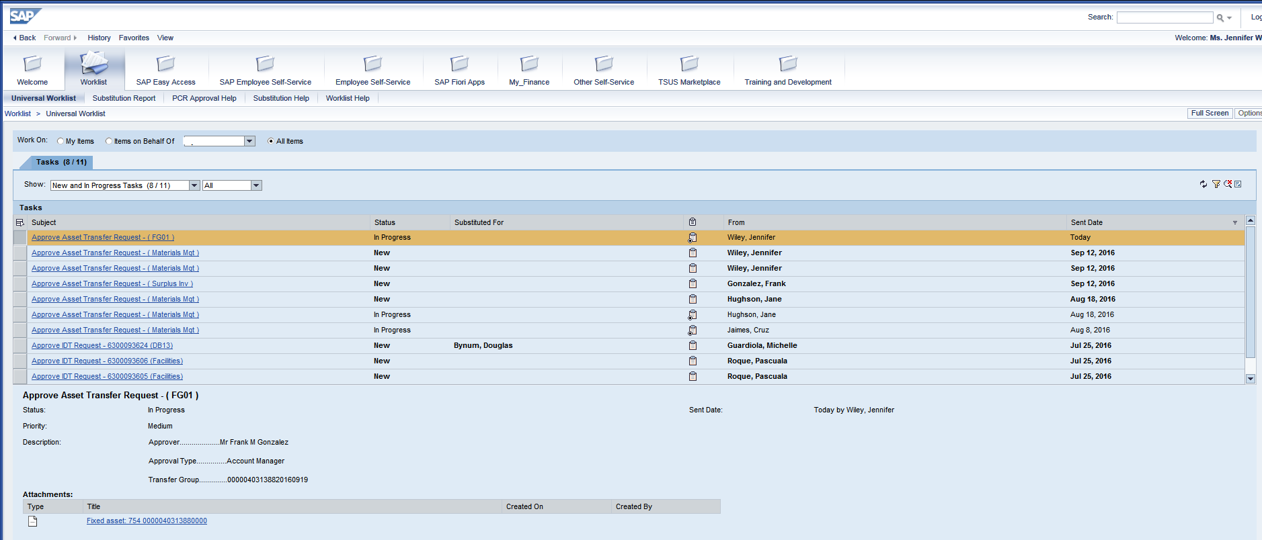
The following screen will appear showing the details of the request:
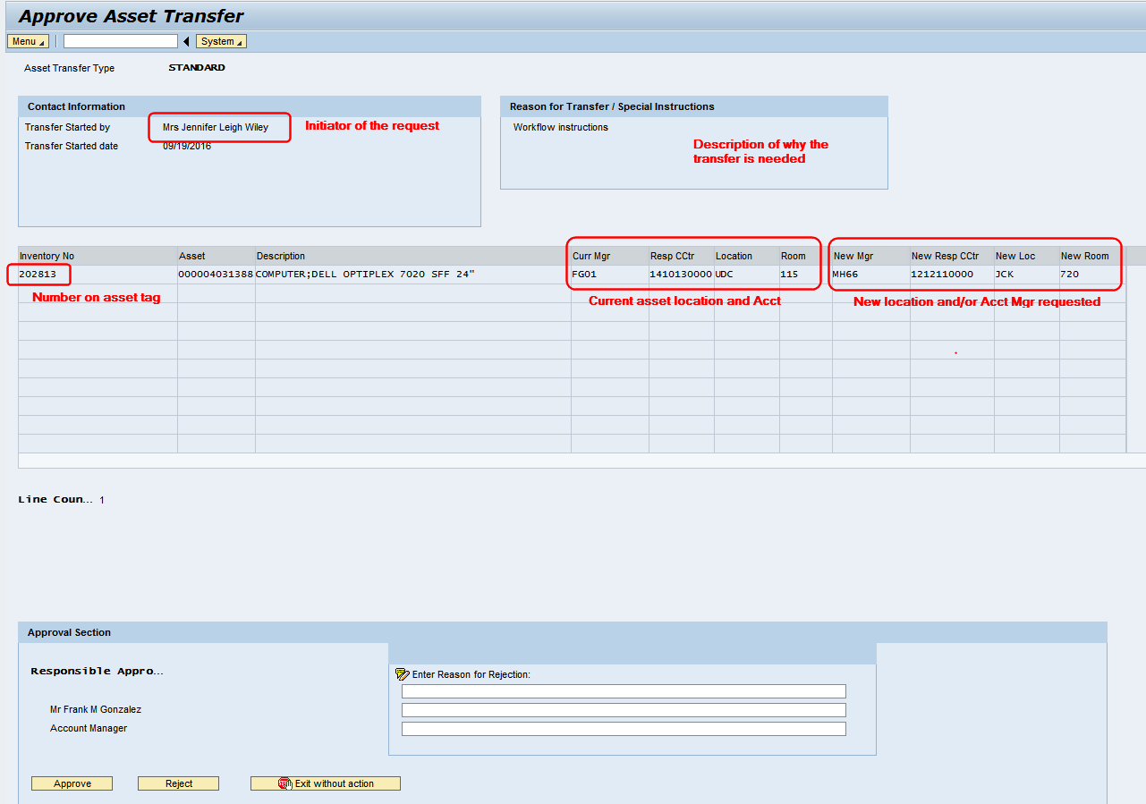
There are three options: Approve, Reject or Exit without action.
If Reject is chosen:
- rejection reason must be entered
- an email will be sent to the initiator with the rejection reason shown

FIORI

This application can be used from tablets or phones by using the portal URL - https://ibis.sap.txstate.edu/irj/portal.

It can also be accessed from a PC by clicking on the SAP Fiori Apps tab:
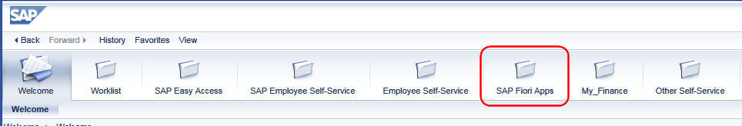
The e-Asset Transfer requests are located in the My Inbox tile
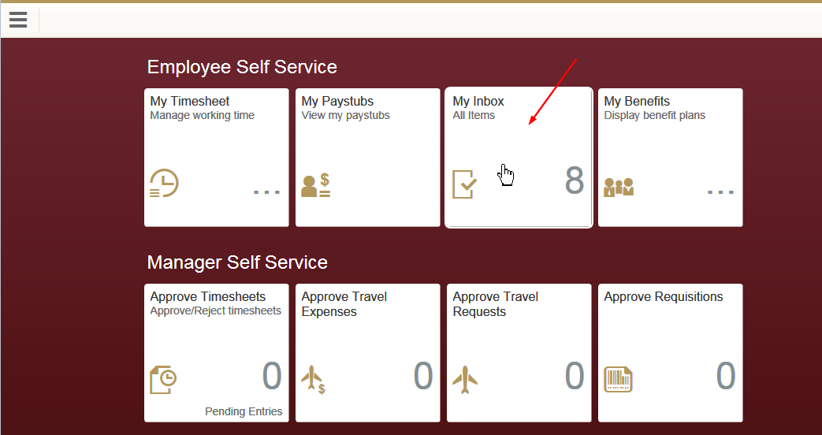
Screenshot of items ready for review:
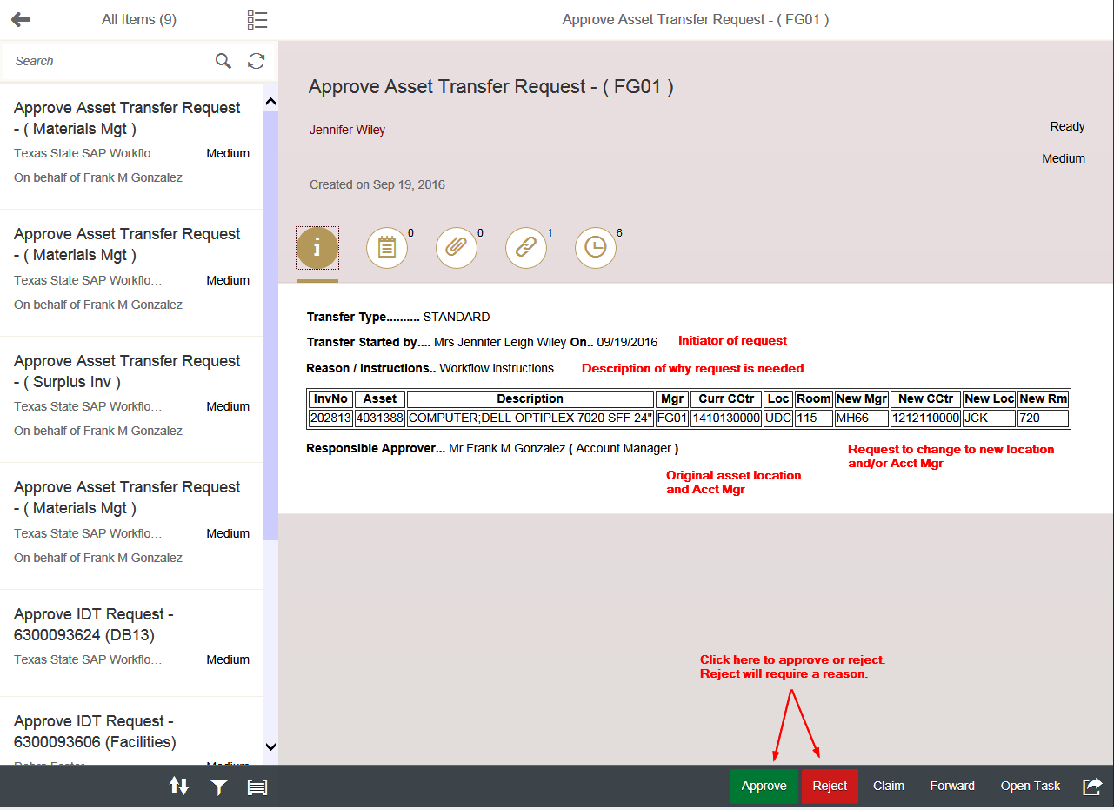
There are two options, Approve and Reject. If rejected, a reason must be given. The reason is included on the rejection email sent to the initiator.

Substitutes

e-Asset Transfer substitutes are included with the group for e-NPO and e-IDT. 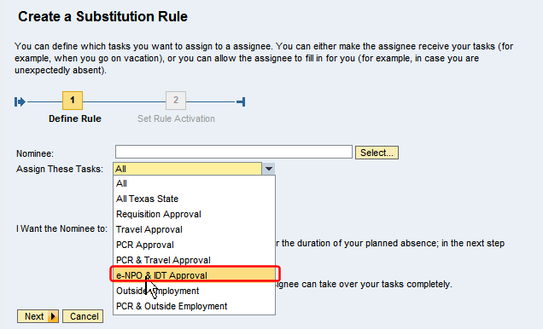
If there is currently a substitute for e-NPO and e-IDT, that substitute is automatically a delegate for e-Asset Transfer, no action is needed to assign a substitute.

