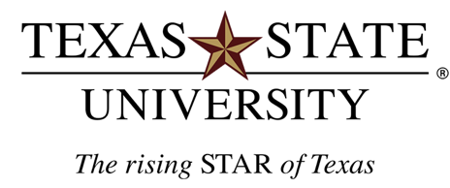

**PHOTO/**VIDEO **RELEASE FORM**

I, ________________________________, give Texas State University and/or the Texas State University System (herein, “Texas State”), its employees, designees, agents, independent  
contractors, legal representatives, successors and assigns, and all persons or departments for  
whom or through whom it is acting, the absolute right and unrestricted permission to take, use  
my name, testimonial and biographical data and/or publish, reproduce, edit, exhibit, project,  
display and/or copyright photographic images, pictures or videos of me or my child(ren), whether still, single, multiple, or moving, or in which I (they) may be included in whole or in part, in color or otherwise, through any form of media (print, digital, electronic, broadcast or otherwise) at any

campus or elsewhere, for art, advertising, recruitment, marketing, fund raising, publicity, archival or any other lawful purpose.

I waive any right that I may have to inspect and approve the finished product that may be used or to which it may be applied now and/or in the future, whether that use is known to me or my child(ren) or unknown, and I waive any right to royalties or other compensation arising from or related to the use of the image or product.

I release and agree to hold harmless/liable Texas State, its Board of Regents, officers, employees, faculty, agents, nominees, departments, and/or others for whom or by whom Texas State is acting, of and from any liability by virtue of taking of the pictures or using the testimonial/biographical data, in any processing tending towards the completion of the finished product, and/or any use whatsoever of such pictures or products, whether intentional or otherwise.

I certify that I am at least 18 years of age (or if under 18 years of age, that I am joined herein by my parent or legal guardian) and that this release is signed voluntarily, under no duress, and without expectation of compensation in any form now or in the future.

____________________________  
Name (Please print)

Signature

_________________  
Date

____________________________________  
Signature of parent or legal guardian if under 18 years of age

___________________________________   
Witness

601 University Drive | San Marcos, Texas 78666 WWW.TXSTATE.EDU

