

**CAPITAL PROJECTS**

**QUARTERLY STATUS REPORT**

February 2023

TEXAS STATE UNIVERSITY

MEMBER **THE TEXAS STATE UNIVERSITY SYSTEM**

This report is organized by the phase that each project is at in the development cycle. The stages include:

1. Planning and Programming Phase – This is the very first activity designed to help us understand what we need and to establish an order of cost magnitude.
2. Design and Construction Document Phase – The process of developing detailed drawings, specifications, and cost estimates.
3. Construction Phase – The process of building the entire project.
4. Completed Projects – The construction is complete, the bills are all paid, the building has been turned over for our use, and the TSUS Planning and Construction Office has officially approved project close out.

When multiple projects are underway in one building, all the projects in that building are presented together for ease of understanding, regardless of their stage in the development process.

**PLANNING AND PROGRAMMING PHASE**

**Ballpark Clubhouse**

**Feasibility Study:** Texas State (FPDC) **Est. Cost:** $9,996,898

The **Ballpark Clubhouse** project will consolidate the baseball locker room and player lounge from the University Events Center to the baseball stadium, add additional spectator seating and hospitality areas, increase the number of practice batting cages, and add a pitcher performance lab that utilizes innovative technology to improve pitching mechanics and development.

**Status:** The feasibility and concept renderings will be used for fundraising purposes. This project is part of the Capital Improvements Program (CIP).

**Next Milestone**: Complete feasibility and fundraising.

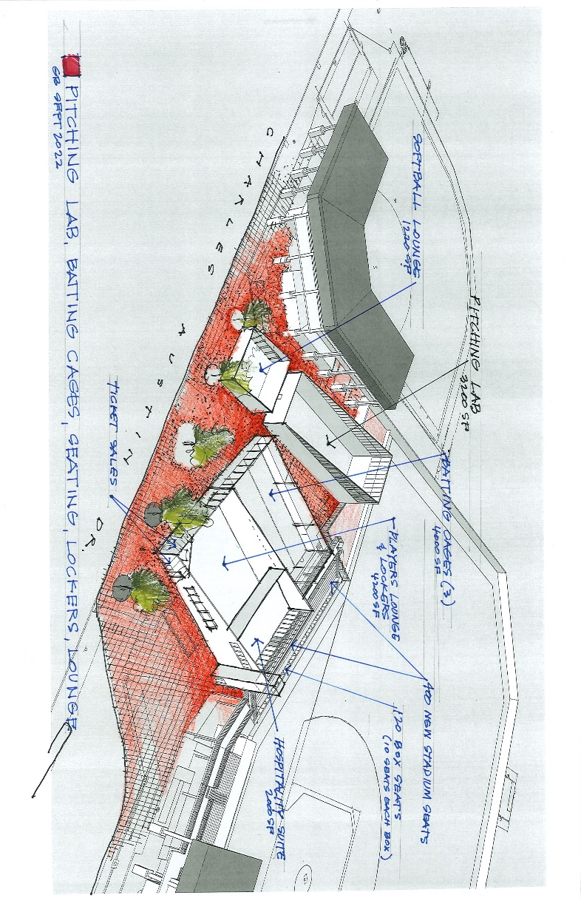

Exterior Rendering - Ballpark Clubhouse

**Music Building**

**Programmer:**  Facility Programming and Consulting **Est. Cost:** $90,000,000

A new **Music Building** will address the pressing needs of the School of Music and will include classrooms and rehearsal spaces. The building will be located next to the Performing Arts Center on the San Marcos Campus.

**Status:** A draft program was prepared for the new **Music Building** in 2010 and updated in 2019, resulting in a desired project size of 110,128 Gross Square Feed (GSF). Due to funding availability and construction inflation, the program of design is being reduced to 85,000 GSF. This project is on the CIP and is to be funded largely through philanthropic contributions. The program and concept renderings will be used for fundraising purposes.

**Next Milestone**: Pending funding availability.

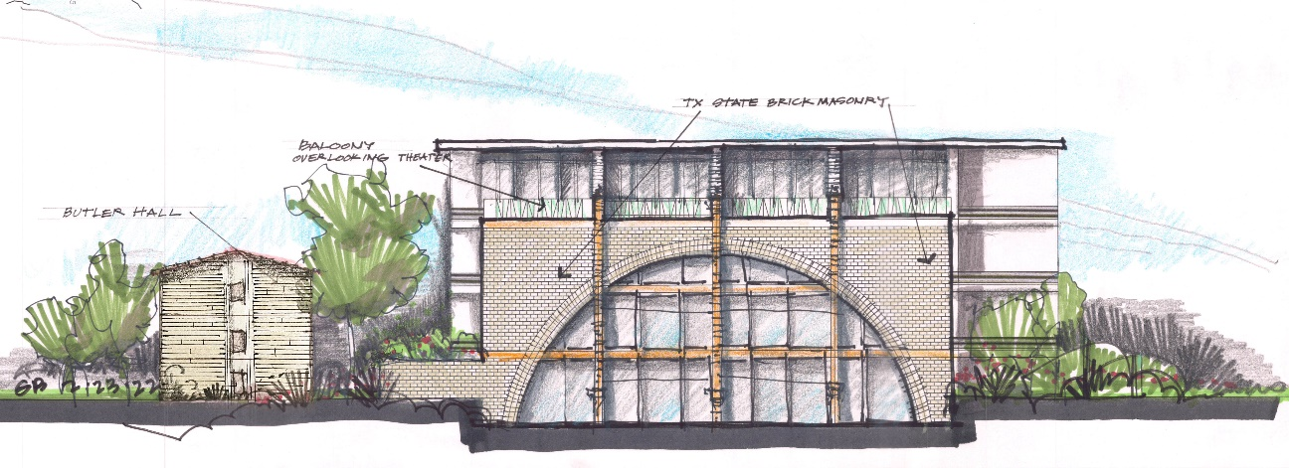

Exterior Rendering – Music Building

**Spring Lake Hall Exhibition and Patio Renovations**

**Programmer:** Feasibility Study **Est. Cost:** $13,310,000

The **Spring Lake Hall Exhibition and Patio Renovations** final feasibility study will provide conceptual images showing a dramatic transformation of the first floor of Spring Lake Hall. The project will result in an interpretive research center using state-of-the-art, integrated, and immersive exhibits. These new exhibits may include the integration of virtual reality, green screen, and avatar technology systems. This project is on the CIP and is to be funded through philanthropic contributions.

**Status:** Concept drawings are complete.

**Next Milestone**: Pending funding availability.

**STEM Classroom Building**

**Programmer:**  Facility Programming and Consulting **Est. Cost:** $137,409,972

The **Science, Technology, Engineering, and Math (STEM) Classroom Building,** located on the San Marcos Campus**,** will house the Departments of Mathematics and Computer Science, and will provide teaching space, class labs, departmental offices, and research labs for several other academic disciplines. The proposed

154,000 GSF building has an estimated Total Project Cost (TPC) of $137.4 million.

**Status**: The program for the STEM Classroom Building is complete. Solicitations for Architect/Engineer and Construction Manager are underway. This project is on the CIP.

**Next Milestone**: Select Architect and Contractor.

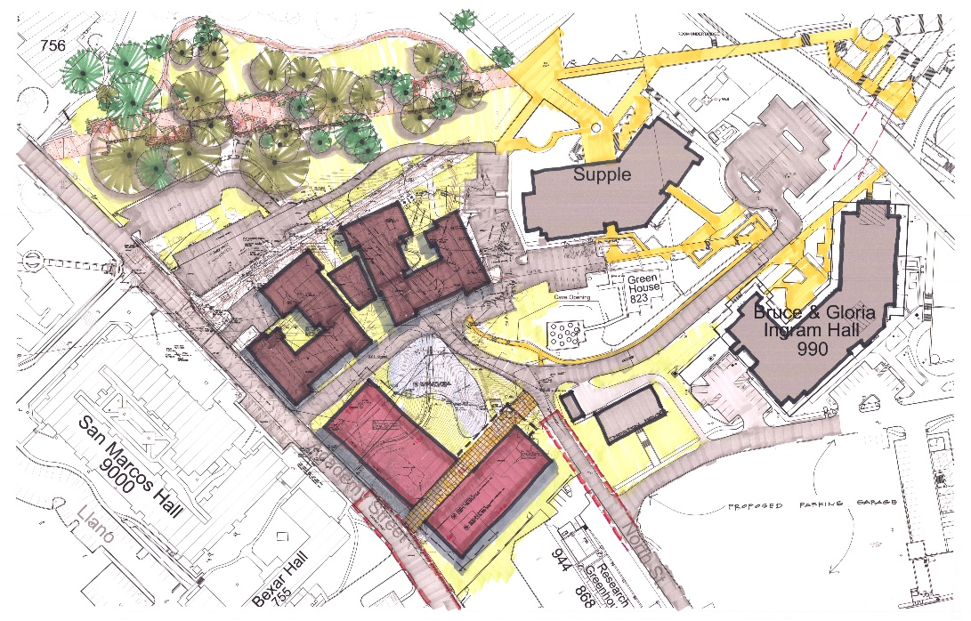

STEM Location Map

**DESIGN AND CONSTRUCTION DOCUMENT PHASE**

**Bobcat Stadium End Zone Complex Expansion**

**Architect:**  Pfluger Architects, Inc.

**Contractor (CMR):** White Construction

**Design Stage:** Design Development

**Est. Cost:** $37,000,000

**Est. Completion:** July 2024

The **Bobcat Stadium End Zone Complex Expansion** project will remodel a large portion of the existing south end zone complex by providing more breakout team rooms in the existing building, relocating the athletic performance center to open into the end zone, connecting the west and east concourse level balcony, and creating an alumni pavilion and deck on the roof of the building.

**Status:** Design Development is underway and will be presented for approval at the February 2023 meeting of the Board of Regents. This project is part of the CIP.

**Next Milestone**: Design Development Approval.

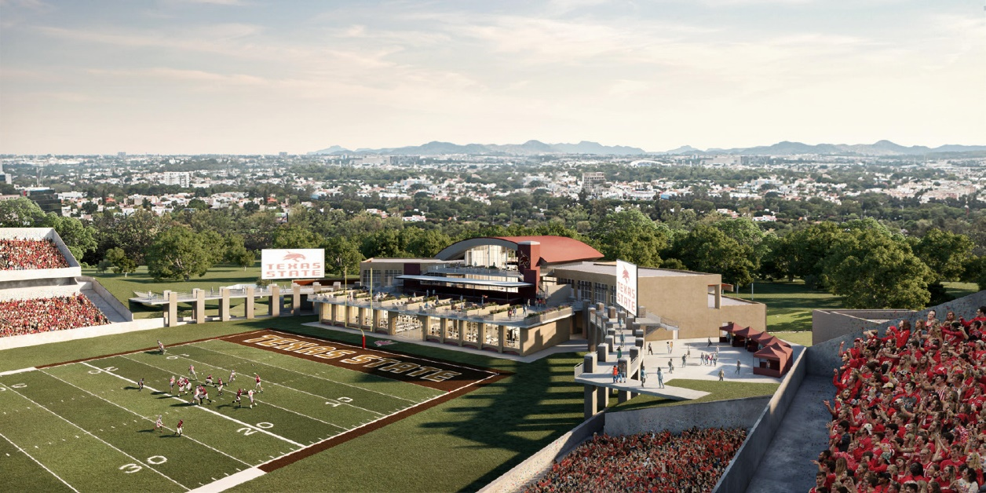

Exterior Rendering - Expansion

**Campus Potable Water System Upgrades - Delegated Project**

**Engineer:** Kimley-Horn (Civil)

**Contractor:** TBD (CSP)

(Ph. 1 - Water Line Extension)

TBD (CSP)

(Ph. 2 - Jackson Hall Pump Site)

TBD (CSP)

(Ph. 3 - Elevated Tower Rehabilitation)

**Design Stage:** Bid / Solicitation

**Est. Cost:** $6,000,000

**Est. Completion:** December 2024 (Projected – all Three Phases)

This project involves the cleaning of the interior and exterior of the existing elevated water tower on the

San Marcos Campus, making repairs as required, and re-painting the tower. The project will be completed in three phases: (1) water line extension, (2) the Jackson Hall pump site, and (3) the elevated tower rehabilitation.

**Status:** Construction documents are being finalized and comments are being addressed with the City of San Marcos. Contractor selection for the water line extension (Phase 1) is underway.

**Next Milestone:** Bidding phase.

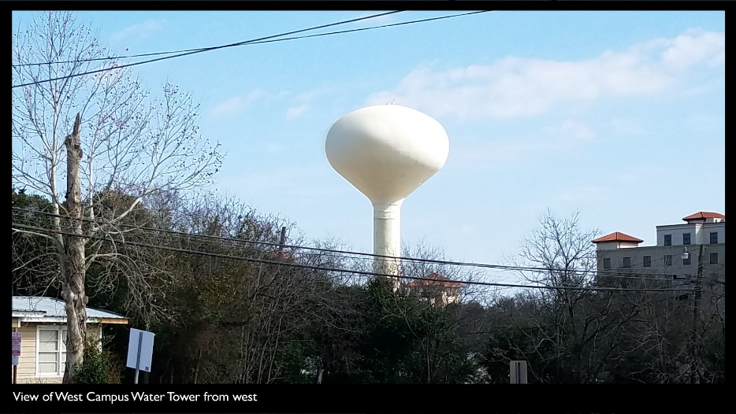

Existing elevated water tower

**Esperanza Hall**

**Architect:** TBD

**Contractor:** TBD (CMR) **Design Stage:** A/E Selection

**Est. Cost:** $52,409,972

**Estimated Completion:** April 2025

**Esperanza Hall** will be the fourth academic building on the Round Rock Campus. It will include classrooms, labs, and offices to support the College of Health Professions, the Advising Center, and support areas.

**Status:** Architect selection has been made and negotiations are underway. Solicitation for Construction Manager at Risk is in progress. This project is on the CIP.

**Next Milestone**: Start Schematic Design.

Esperanza hall site location. South of Avery.

Esperanza site location

**JC Kellam (JCK) Administration Building Reconfiguration**

**Architect**: Gensler

**Contractor (CMR):** Flintco

**Design Stage:** Construction Documents

**Est. Cost:** $5,975,000

**Est. Completion:** August 2023

The **JC Kellam Administration Building Reconfiguration** project is the first major improvement to the building in over 30 years. This project will convert the eleventh-floor meeting space into event space for various functions.

**Status**: Construction documents and estimates are currently being developed.

**Next Milestone:** Complete Construction Documents.

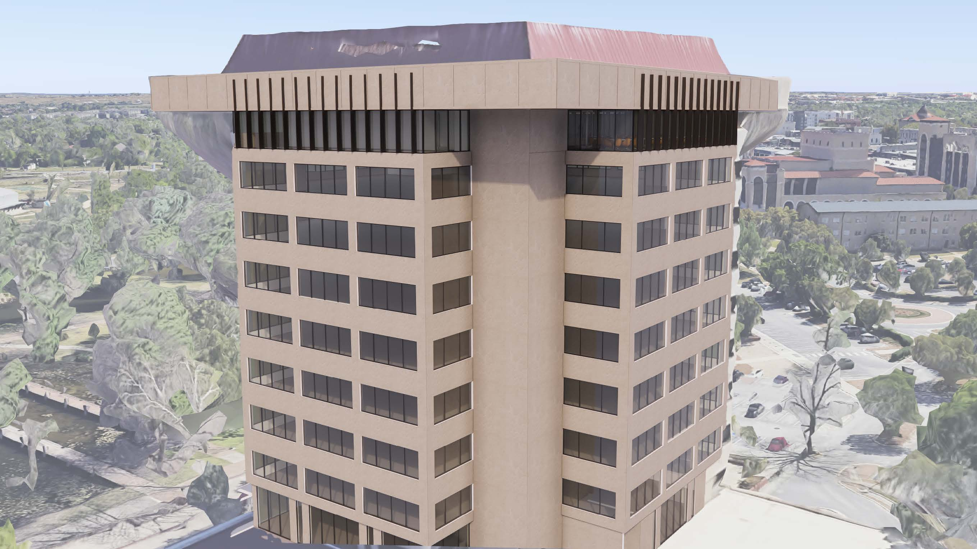

Exterior Rendering

**CONSTRUCTION PHASE**

**ALERRT Center Office and Parking - Delegated Project**

**Architect:** Kimley-Horn (Civil)

**Contractor:** TBD

**Percent Complete:** 0%

**Est. Cost:** $1,900,000

**Est. Completion:** TBD

The base scope of the **ALERRT Center Office and Parking** project includes parking for approximately

40 cars, an access road to the site from the main entry, infrastructure to support modular office space, meeting rooms, a break room, and bathrooms for approximately 32 staff. The project also includes bringing a new

fiber-optic data line to the ALERRT Center from the San Marcos Campus and setting up suitable streaming video for the offices and meeting rooms.

**Status:** The project is on hold pending property disposition by the United States Department of Labor.

**Next Milestone:** Resolution of land ownership issues with the United States Department of Labor.

**Hilltop Housing Complex**

**Architect:** Barnes Gromatzky Kosarek

**Contractor (CMR):** JT Vaughn Construction

**Percent Complete:** 18%

**Est. Cost:** $125,165,442

**Est. Completion:** May 2024 (Projected)

The scope of work for the **Hilltop Housing Complex** includes the demolition of Hornsby andBurleson Halls, utility upgrades, the construction of two seven-story student housing structures to accommodate 1,006 beds and comprising 241,000 GSF.

**Status:** Structural and foundation work on both towers is underway.

**Next Milestone:** Complete foundation.

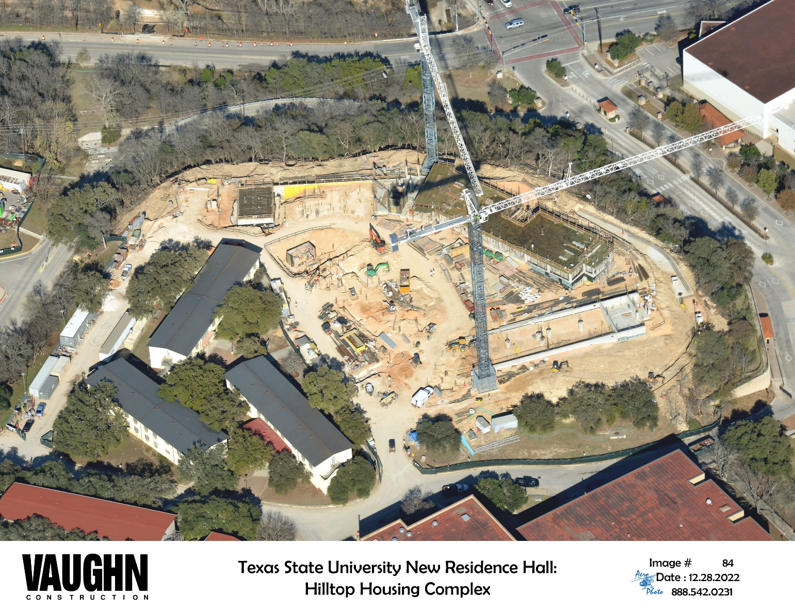

Aerial Photo of Site

**Nueces Building Renovation (previously Testing Center Relocation) – Delegated Project**

**Architect:** PBK Architects

**Contractor (CSP):** SpawGlass

**Percent Complete:** 70%

**Est. Cost:** $5,944,854

**Est. Completion:** March 2023 (Projected)

The **Nueces Building Renovation** project will renovate the space vacated by the University Police Department following their move into the new Pecan Building. It will convert the space into a new 13,800 square foot space for the Testing, Evaluation, and Measurement Center which is currently housed in Commons Hall.

**Status:** Mechanical replacement is complete. Painting and casework installation is on-going.

**Next Milestone**: Complete interior finishes.

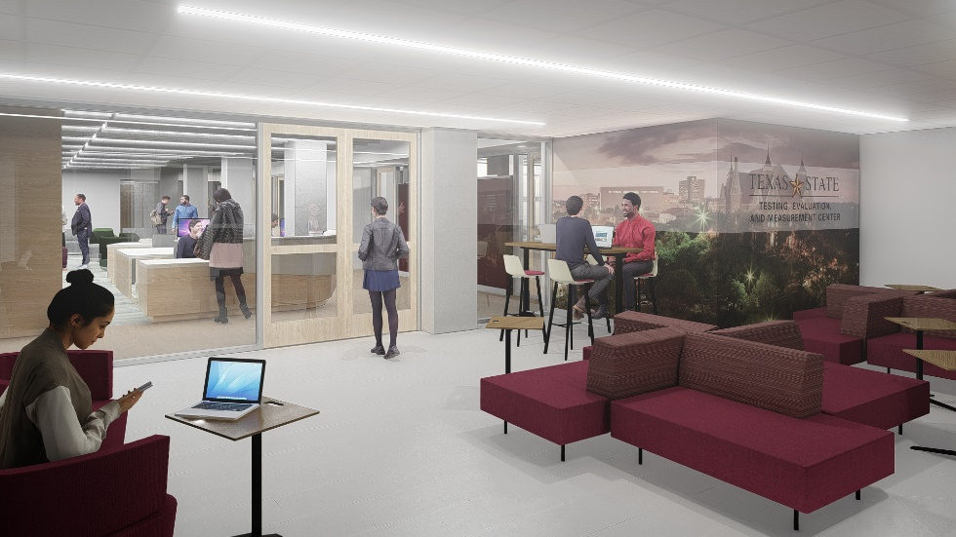

Rendering of TEMC Lobby

**COMPLETED PROJECTS**

**Bobcat Stadium Seating Anchor Replacement**

The **Bobcat Stadium Seating Anchor Replacement** project, with a TPC of $2,200,000, reached substantial completion in May 2022. The final report is being prepared.

**Evans Auditorium Renovation – Delegated Project**

The **Evans Auditorium Renovation** project, with a TPC of $3,000,000, reached substantial completion in August 2022. The final report is being prepared.

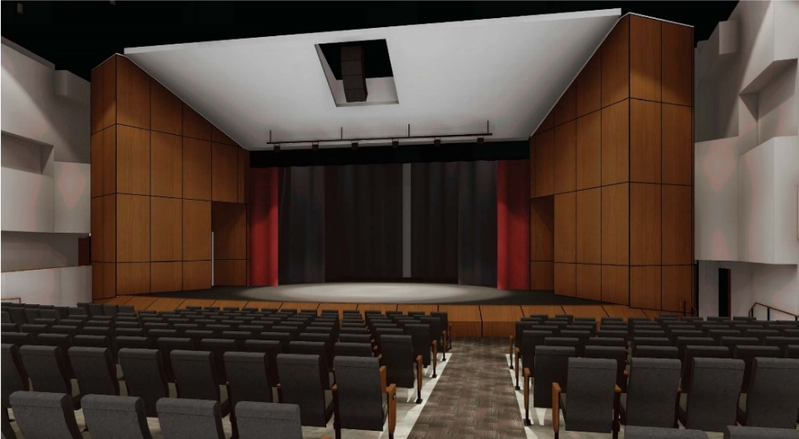

**Infrastructure Research Laboratory (STAR Park)**

The **Infrastructure Research Laboratory** project, with a TPC of $14,026,687, reached substantial completion in December 2022. The final report is being prepared.

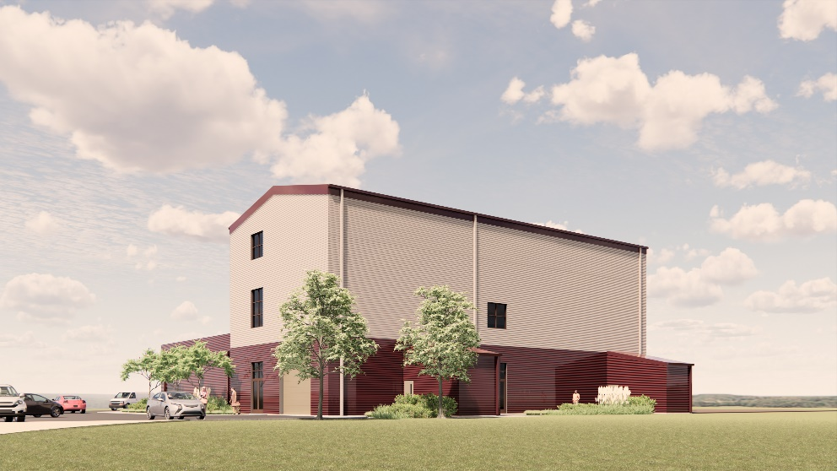

**Live Oak Hall (previously Film and Television Studios)**

**Live Oak Hall**, with a TPC of $10 million, reached substantial completion in May 2022. The final report is underway.

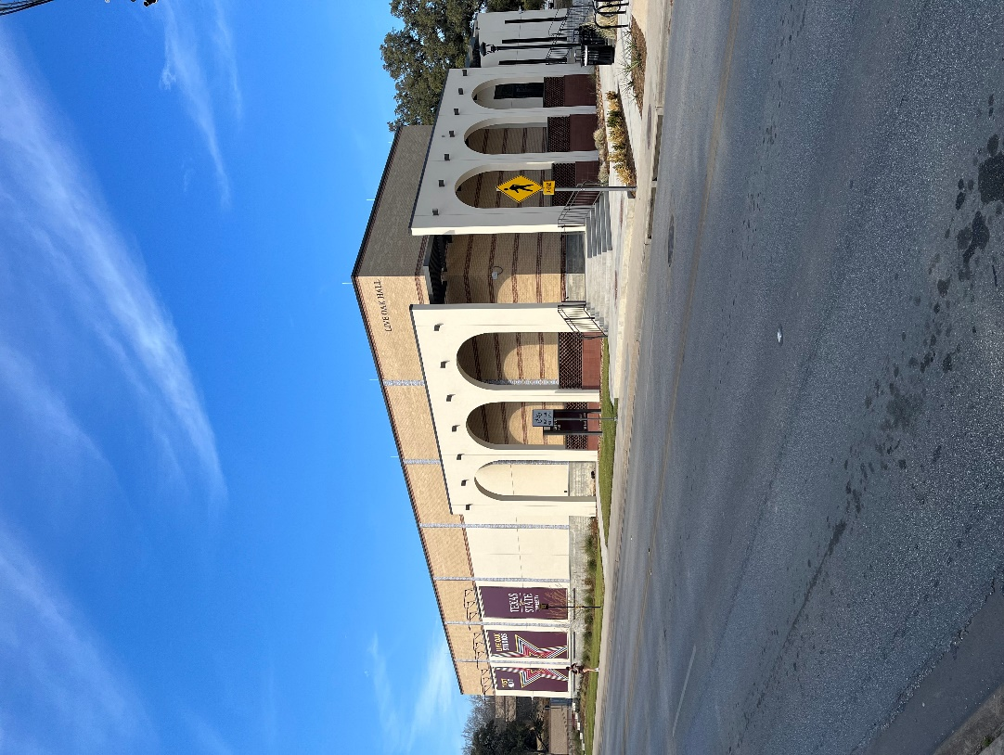

**Pecan Building (previously University Police Department Building)**

The **Pecan Building** project, with a TPC of $9 million, reached substantial completion in October 2021. The final report is being submitted for the February 2023 Board of Regents Meeting.

