Author
Senator Bailey, Brett

Sponsors
Senator Florence, Andrew Senator Mack, Chris

Articles of Impeachment -

Convicting Colton Halter, Texas State University Senator At-Large of violations eligible for impeachment, according to the Texas State University Student Government Code, TITLE II, ARTICLE II, Section 3 Ethical Standards (b), (e), (g)
violation(s) of the rules, regulations and laws of the Student Government.

Whereas: The following Articles of Impeachment are granted to be conducted under trial:

Article I

Colton Halter, Student Body Senator-At-Large, has gross violations of the Student Government Code: CODE OF ETHICS, Title II, Chapter 100, Article II ETHICAL STANDARDS, Section §3. (b) refusing to oppose all forms of discrimination and harrassment
As evidenced in Appendices A-C, Colton Halter, engaged in hostile written attacks wishing for “#DeathToAmerica”, calling for the “cancelling” of white people, and making offensive comments Governor Gregg Abbot for his disability. It is clear in the Appendices that Colton Halter has no regard for the feelings of the students he represents and in Appendix A will even go so far as to openly call for the death of their nation. This is discriminatory against many groups of the student body and a gross violation of the Code of Ethics.

Article II

Colton Halter, Student Body Senator-At-Large, has gross violations of the Student Government Code: CODE OF ETHICS, Title II, Chapter 100, Article II ETHICAL STANDARDS, Section §3. (e) be compassionate, benevolent and fair
These posts in Appendices A-C are grossly in violation of the Ethical Standards of being compassionate, benevolent and fair. It is not compassionate to mock an individual's disability. It is not benevolent to call for the death of an entire nation. Nor is it fair to call for the cancelling of an entire race based on a tweet. Colton Halter is in gross violation of this Ethical Standard.

Article III

Colton Halter, Student Body Senator-At-Large, has gross violations of the Student Government Code: CODE OF ETHICS, Title II, Chapter 100, Article II ETHICAL STANDARDS, Section §3. (g) be respectful and exemplify the principles of servant leadership when speaking with constituents
In Appendices A-C Colton Halter calls for the death of the nation, the cancelling of a race, and mocks Governor Abbot’s disability. It is not respectful of his constituents who are of this nation, may be of the attacked race, or students who may have admiration for Governor Abbot for his overcoming of his disability to reach the high office of governor. By being overwhelmingly inconsiderate of his constituents Colton Halter has neglected the principles of servant leadership. Furthermore Colton Halter should know that a public social media in which he reveals himself as a “txstsg Senator” is a platform through which he is communicating with his constituents. His

disregard for his constituents and utter disrespect of them is a gross violation of this Ethical Standard.
Therefore,

BE IT RESOLVED: That Colton Halter is considered to be unfit for his office as Senator-At-Large; and
BE IT FURTHER RESOLVED: That Colton Halter is removed from his position as Senator-At-Large; and
BE IT FURTHER RESOLVED: That upon the first reading, this resolution be sent to the Acting Supreme Court Chief Justice William Frank-Cadoree for further action; and
BE IT FURTHER RESOLVED: That upon passage voted on in a joint House and Senate session, Colton Halter be removed from his position as Senator-At-Large; and
BE IT FURTHER RESOLVED: This resolution be submitted to Student Body President Corey Benbow, the Chief Justice of Supreme Court, Assistant Dean Kathryn Weiser, Dean of Students Dr. Margarita Arellano for further action.

Appendix A

wJ .y ,en e a onv-c r Criminal Practice •
_e
?
Colton Halter
c uhalter colton

Spanish I I ·•• , ( \, I !
Economics, Political Science, Co-Chair I · , ·., ,, ; Senator I

r .1 I ) r, 'It! ' I {_ :i/\: 11 'I I (
710 F 0I101.ving 182 Follov;cr s
OESALVD \11.'\1,a,
C AMA RGO
·olluvvc•cl by '.::;tuclcnt'.; 1·1r,.t
Ol('\/('I, C:1tllc1 irH· W1ck(•r, .-111d V:ilc11ti11i.

T-\.'ieets Tweets & replies Media Likes

Pin11ecl Tvvect
Colton Halteir (cuhalter colton - 2d
fact, l
You
do,
in
lo v e to see it

Who w:ill win the Iowa caucuses?
IDliYa wt l I vOh! on Feb. .r d.

- S a n d o •• i• fo u u :::.a ■t ed lo w i n
0"'10-f' g o f :27% of th o vo ui In •aw a . In 804¼
o f .sirn u l t l,a,n :s. h w n•b o t w e o n 9'% .a.nd 4 3 % o f the vo ·t e. H e h111e l!I 1 In 3 l=]3"l chance of -wlnnhi g the mast 'ofOl e s ,
e11se n t ia JIY Lie-d 'Will.h the saccind moE l ll k e l)" w-l n n a r;. • B ld ieil"! , w h o hn11 a 11 In 3 f3'21ill
Who will win the New Hamp hirep r i m ary ?

- 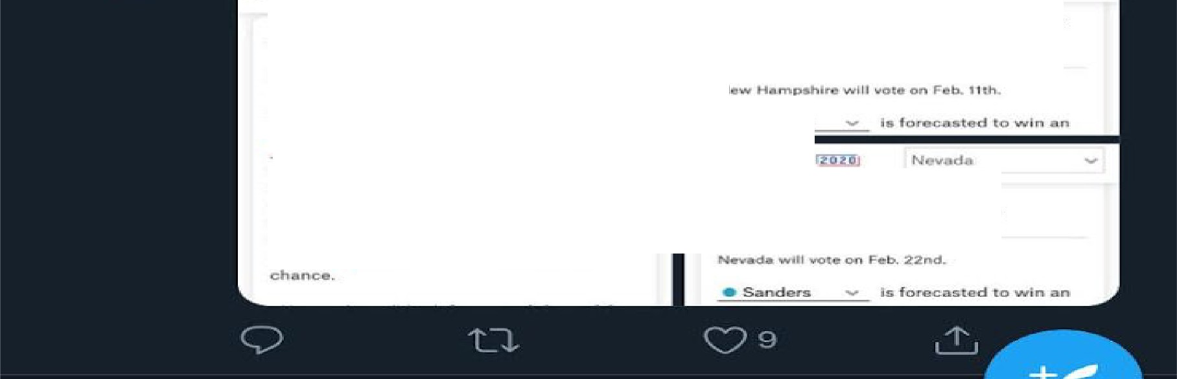S ;i,nd 1131re;

F 1va: T llli.n',1E tRl'l t
Who will mnthe e ada caucuses ?

Appendix B
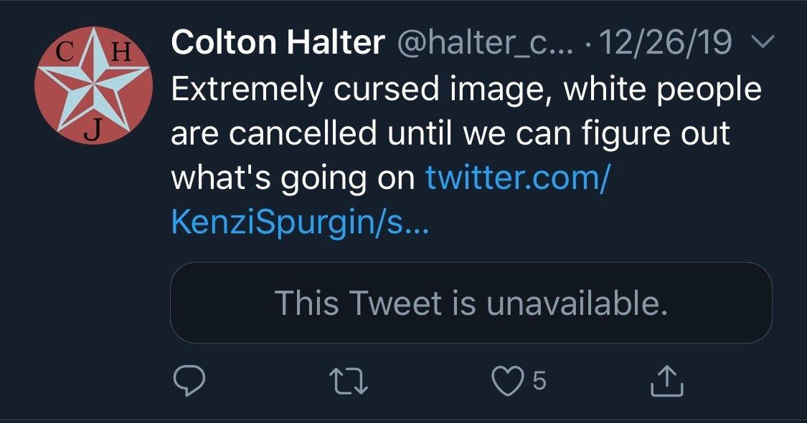

Appendix C
