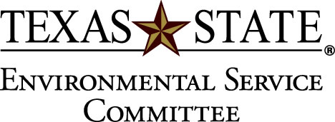

September 22, 2010

- Recap of Sustainability Exploration by Kayte, Alix, and Nancy
  - Went really well!
  - Extra food and tshirts
- Watch Net Impact Line Drying video
  - Texas State won 3nd place nationally for this video
- Lindsey May’s Rainwater Collection project
  - She will be present next meeting to present and discuss
- Dr. Cade wants to take a trip to the compost site
  - Date decided on: Wednesday, Oct. 13 at 5:15 pm
  - Will work out carpooling
  - Nancy volunteered to drive 5 or 6 people
- Possible meeting room change
  - Will remain in 314 because of the fire
- Solar Station for next week needs volunteers
  - Email Dr. Galloway if interested (Galloway@txstate.edu)
- General discussion and announcements
  - Stephanie Bledsoe wonders why there aren’t compostable cups at dining halls and who she can get in touch with to share her concerns
  - Richard Medina and Dr. Tina Cade met to discuss extending Bobcat Blend to residence halls, and are considering piloting the program at Bobcat Village
  - Mark Carter asks what the outcome of last year’s AMA marketing campaign was.
    - There was a Facebook group, list of organization presidents, suggested letter, and brochures
    - Brochures will be distributed during No Impact Week
- Group picture is taken for the bulletin board
- Adjourn

