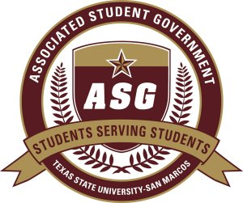

Author:
Senator River Holley
Sponsors:
Senator Christopher Ramirez
Senator Drew Skotak
S.B.F 2011-2012/4
Date of First Reading: 9-12-2011
“Executive Cabinet Expansion”
WHEREAS: The Associated Student Government strives to represent the student body of Texas State University; and
WHEREAS: The student body of any extension of Texas State University- San Marcos deserves the same representation as any other student enrolled at Texas State University- San Marcos; and
WHEREAS: The Round Rock Higher Education Center consist of a unique and diverse community which last semester held 1,980 students of its own; and
WHEREAS: Currently the Round Rock Higher Education Center does not have a representative to voice the ideas and issues that are present on that campus; and
WHEREAS: Creating a direct line of communication to the Associated Student Government would allow for equal representation on both campuses alleviating both current and future issues; therefore
BE IT ENACTED: That the ASG Code of Laws be amended in Article III, Section I, Subsection E by adding a 15th position on the Executive Cabinet for a student representative from the Round Rock Higher Education Center to meet regularly with the current members of the Executive Cabinet to better allow effective communication between the two campuses.
BE IT FURTHER ENACTED: That Article III, Section I, Subsection E read as follows:
E. The Round Rock Higher Education Center will:
1. Sit on the Executive Cabinet
2. Be a student of the Texas State University Round Rock Higher Education Center
3. Serve as the voice of ASG in affairs that deal directly with the Round Rock Higher Education Center
4. Work with the Associated Student Government to foster greater representation of the students at the Round Rock Higher Education Center

5. Deliver bi-monthly reports to the ASG President and Vice-President
6. Deliver reports to the ASG Senate and ASG Graduate House upon request
And;
BE IT FURTHER ENACTED: that all subsequent sections within the Associated Student Government Code of Laws be amended as necessary; and
BE IT FURTHER ENACTED: That this piece of legislation be forwarded to ASG Advisor Kathy Weiser, Vice President for Academic Affairs Dr. Gene Bourgeois, Dean of Students Dr. Arellano, Vice President of Student Affairs Dr. Joanne Smith, President Dr. Denise Trauth, and RRHEC Director Edna Rehbein upon passage.

