SB20 Requirements for SAP and Marketplace POs
Once you determine the vendor, the vendor is required by federal and state governments, to be checked to determine if there are any sanctions or debarments that would prohibit the university from doing business with them for ALL purchases $15,000 and above. The sites are:

https://mycpa.cpa.state.tx.us/coa/ - Franchise Tax
https://usfcr.com/search-federal-contracts/ – Federal Debarment- SAMS Check
https://fmcpa.cpa.state.tx.us/tpis/ - Vendor Warrant/Payment Hold
https://comptroller.texas.gov/purchasing/programs/vendor-performance-tracking/debarred-vendors.php - Texas Debarment
https://treasury.gov/about/organizational-structure/offices/Pages/Office-of-Foreign-Assets-Control.aspx - The OFAC
**https://comptroller.texas.gov/purchasing/publications/divestment.php - This is the Comptroller site that has all the links except OFAC

See User Guides for Attaching a Document.

**Please note that Marketplace has a limit of only ten attachments. We recommend condensing the Divestment Statute Lists (PDFs) into one attachment.

https://mycpa.cpa.state.tx.us/coa/ - Franchise Tax
- Enter Entity (Vendor) Name
- Select ‘I’m not a robot’
- Click Search
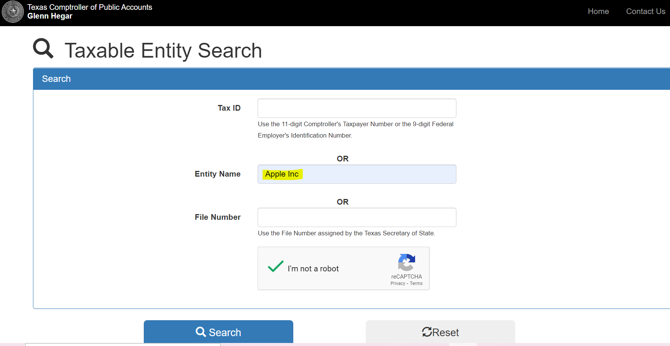

Click ‘Details’
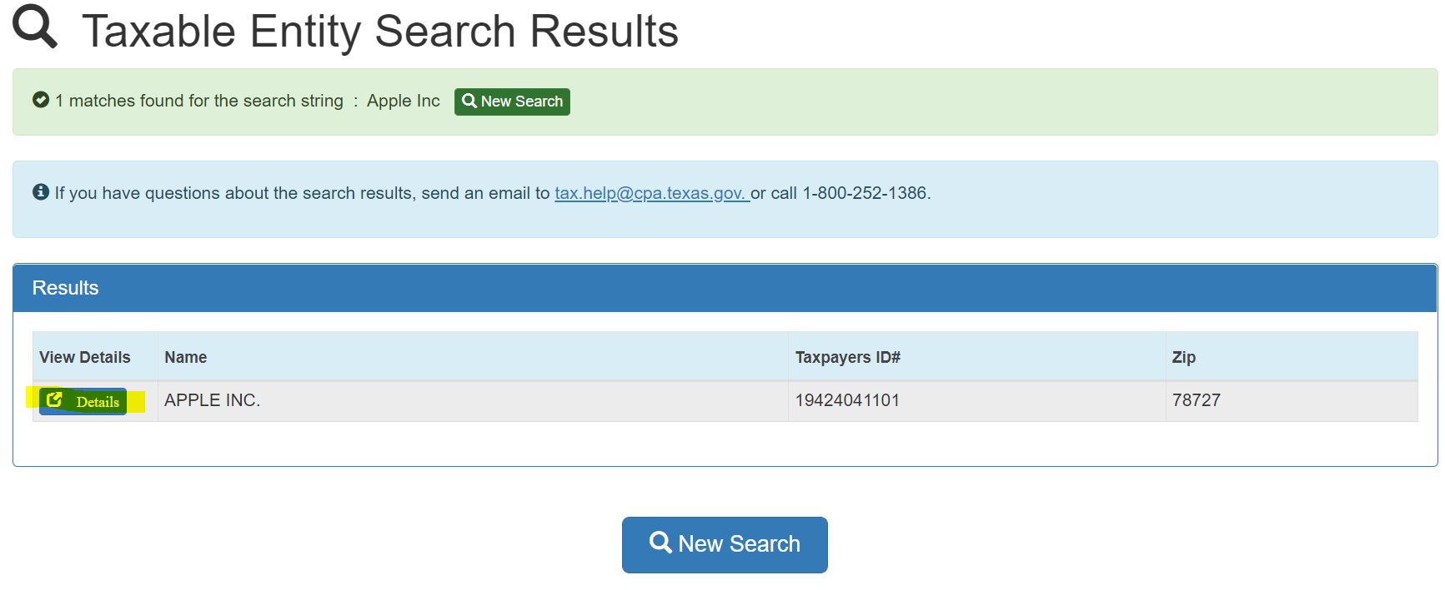

Click the ‘Printer’ icon
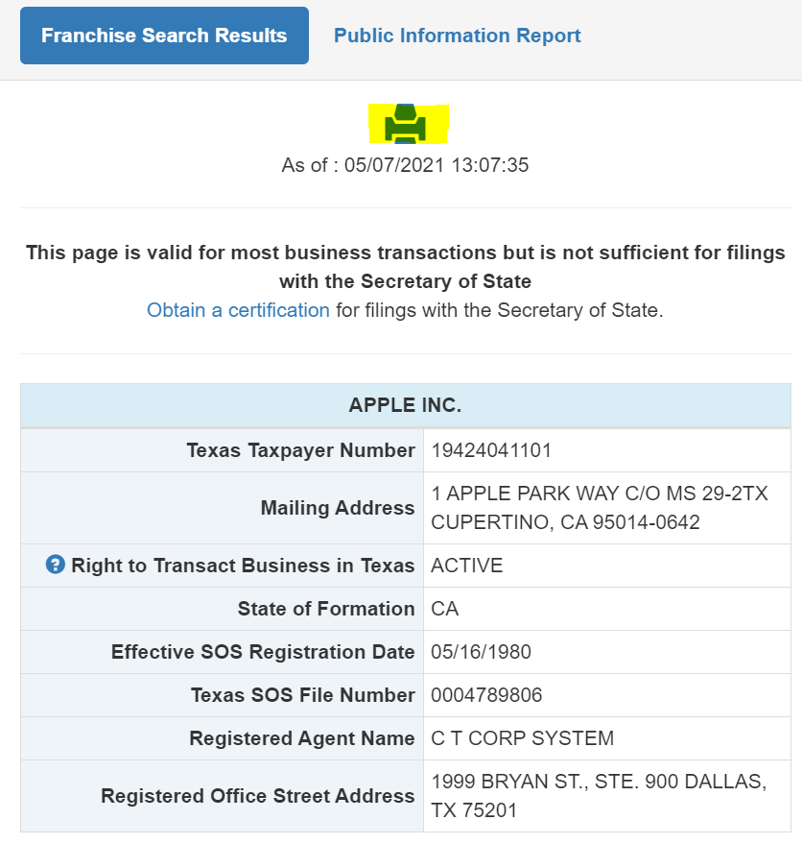

Save as PDF
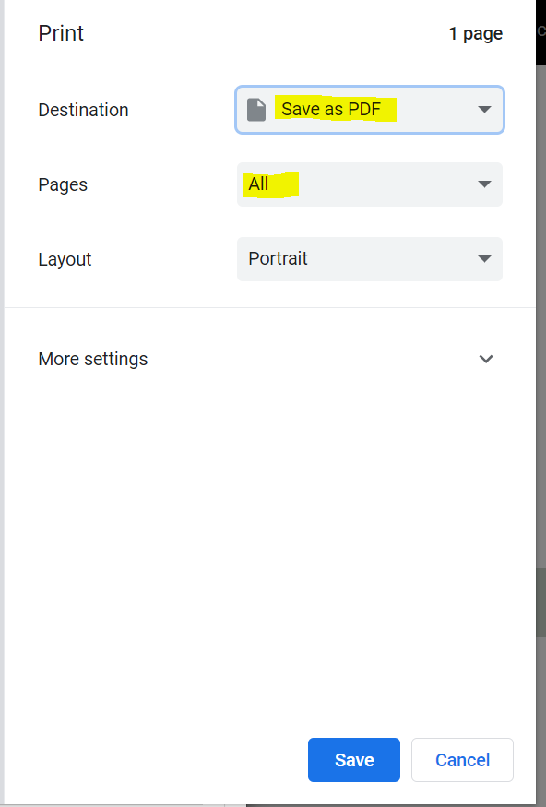
https://usfcr.com/search-federal-contracts/ – Federal Debarment- SAMS Check

- Enter Vendor name
- Change ‘Search Record Type’ to Vendors
- Change ‘Registration Status’ to Active
- Click Apply Filters
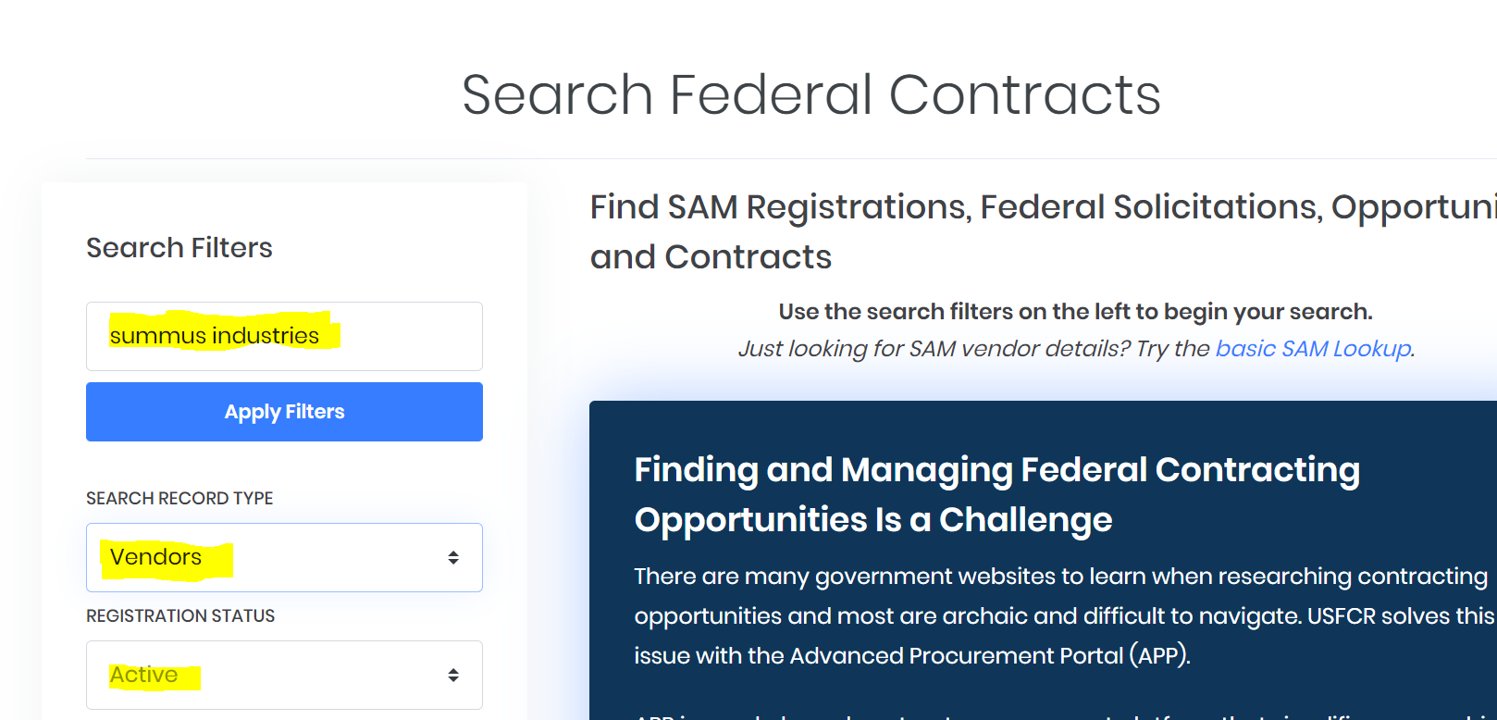

- Select the correct Vendor name from the list
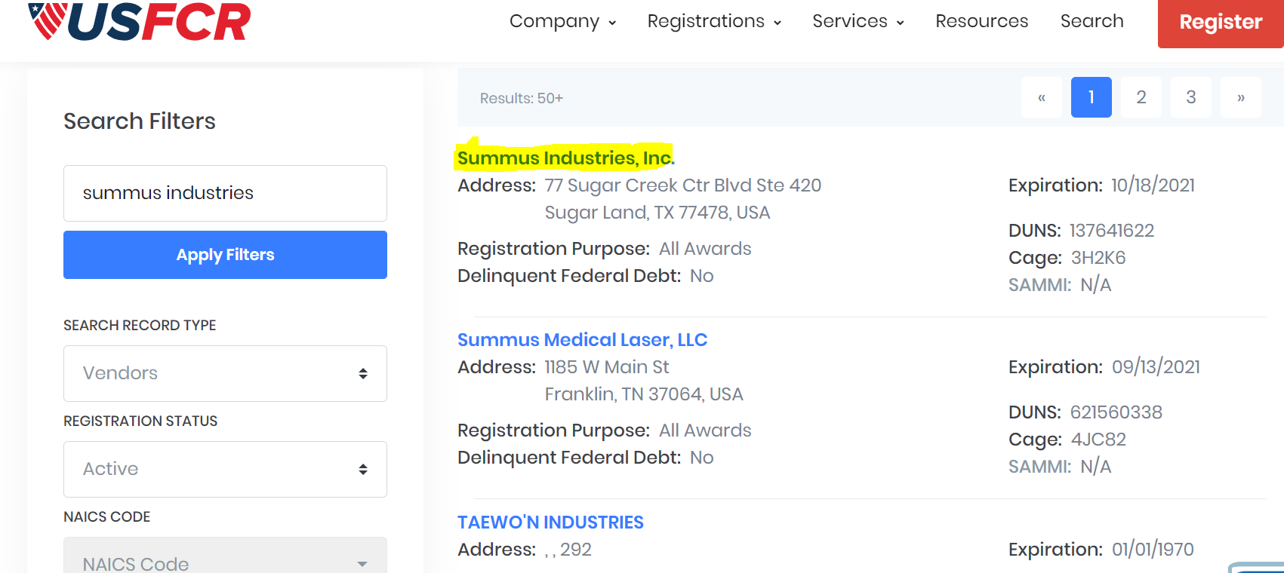

- You will save this page as PDF and attach to requisition
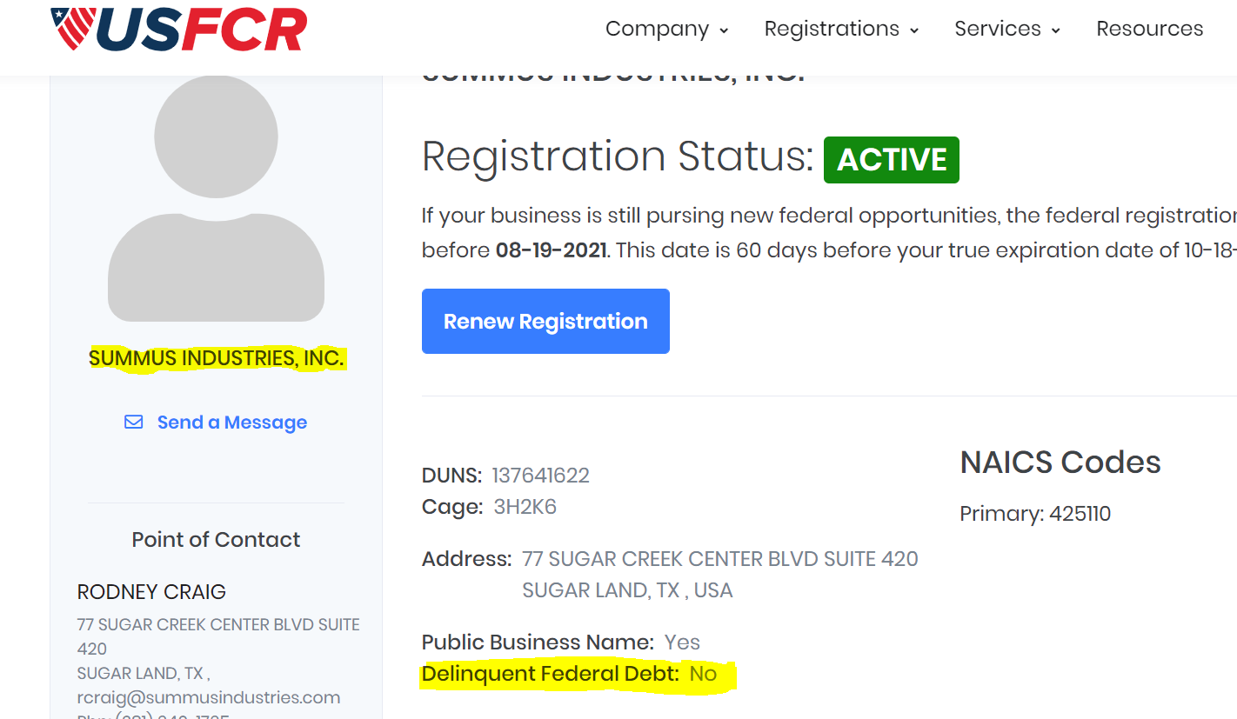

- Save as PDF
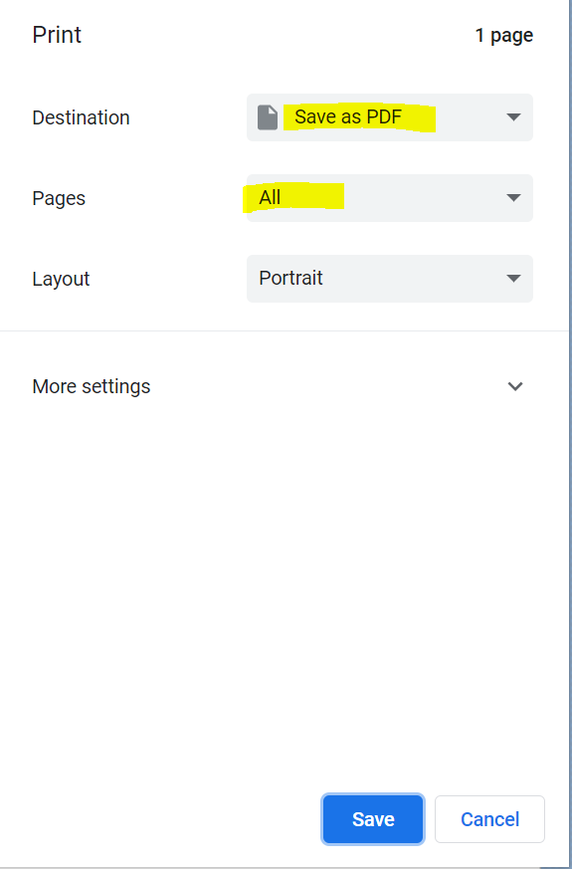

https://fmcpa.cpa.state.tx.us/tpis/ - Vendor Warrant/Payment Hold
Enter Vendor Name and click Search
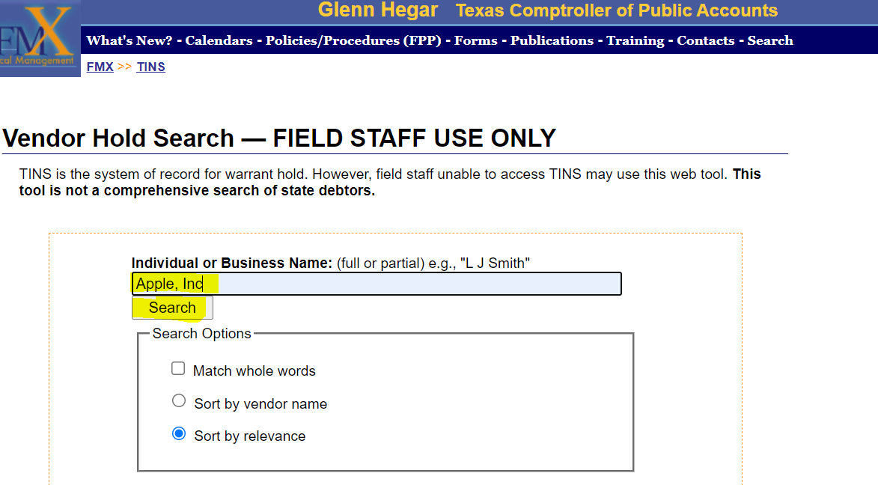

Right click anywhere on the page and select Print
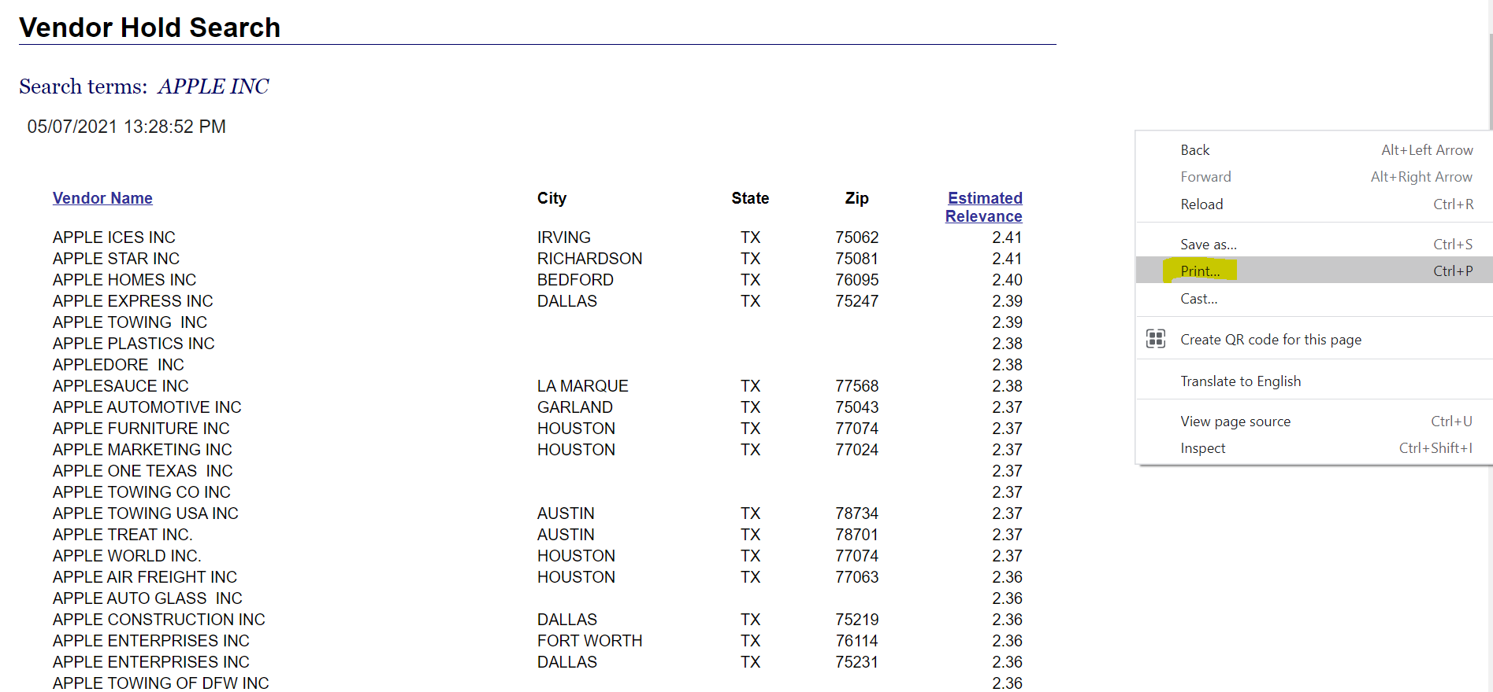

Save as PDF

https://comptroller.texas.gov/purchasing/programs/vendor-performance-tracking/debarred-vendors.php - Texas Debarment
Click Download Debarred Vendor List (PDF)
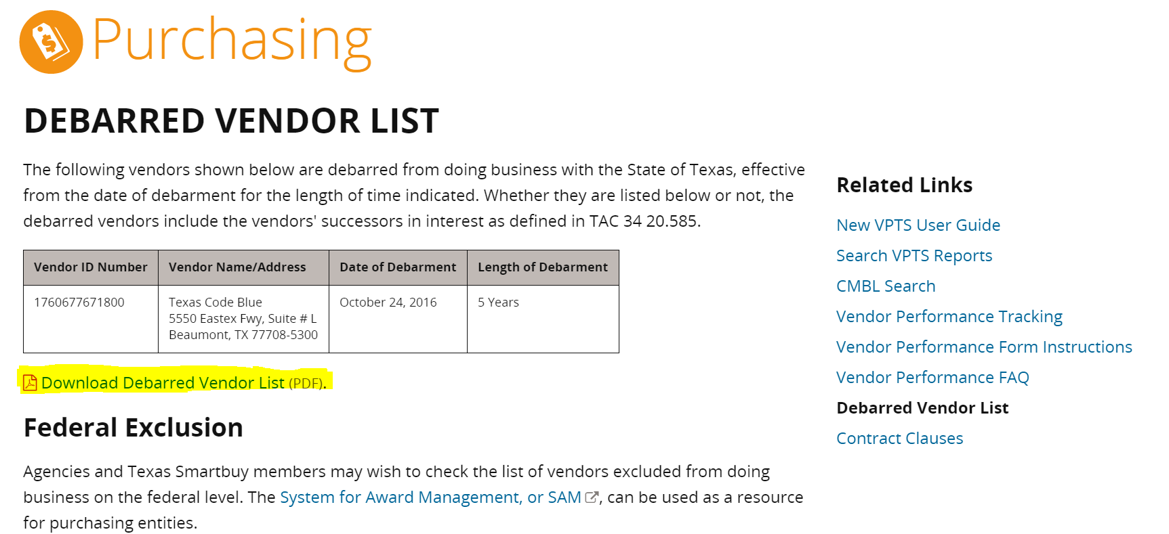

Click the Printer Icon on the top right corner
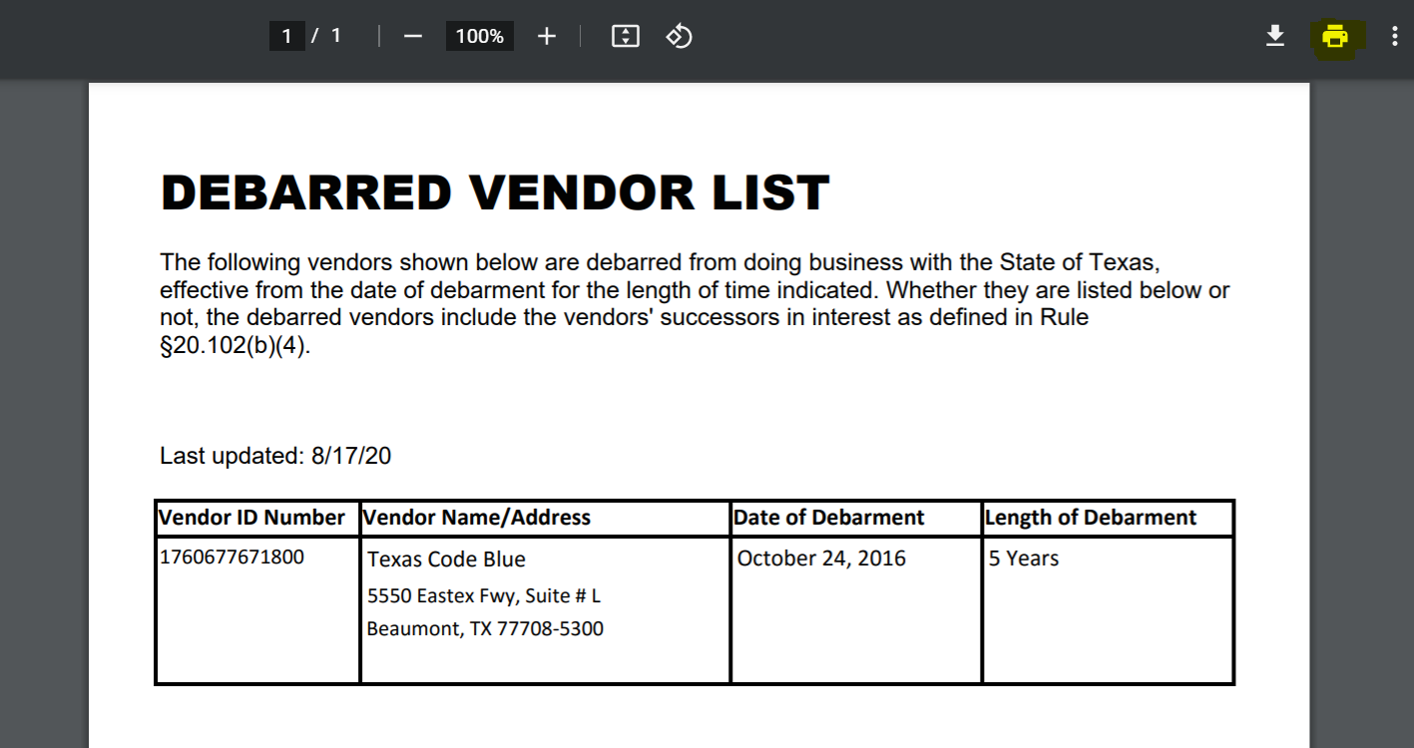

Save as PDF

https://treasury.gov/about/organizational-structure/offices/Pages/Office-of-Foreign-Assets-Control.aspx - The OFAC
Click Search OFAC’s Sanctions List
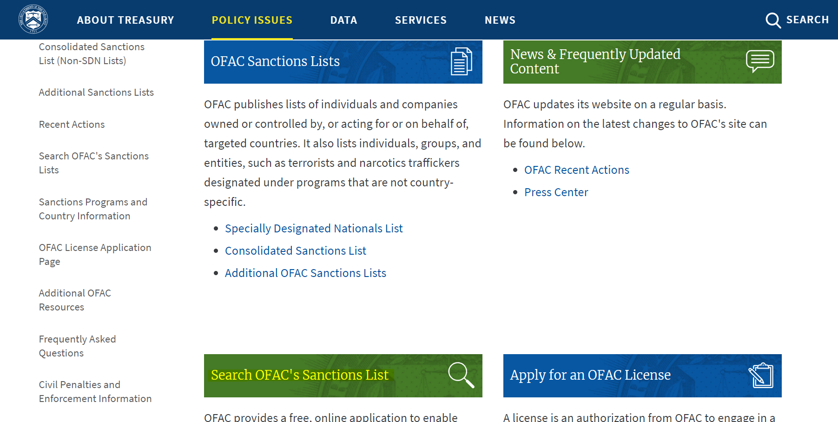
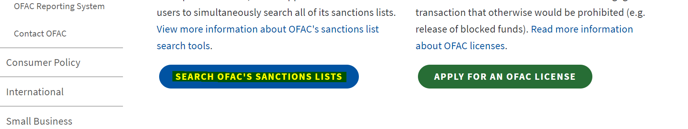

Enter Vendor Name and click Search
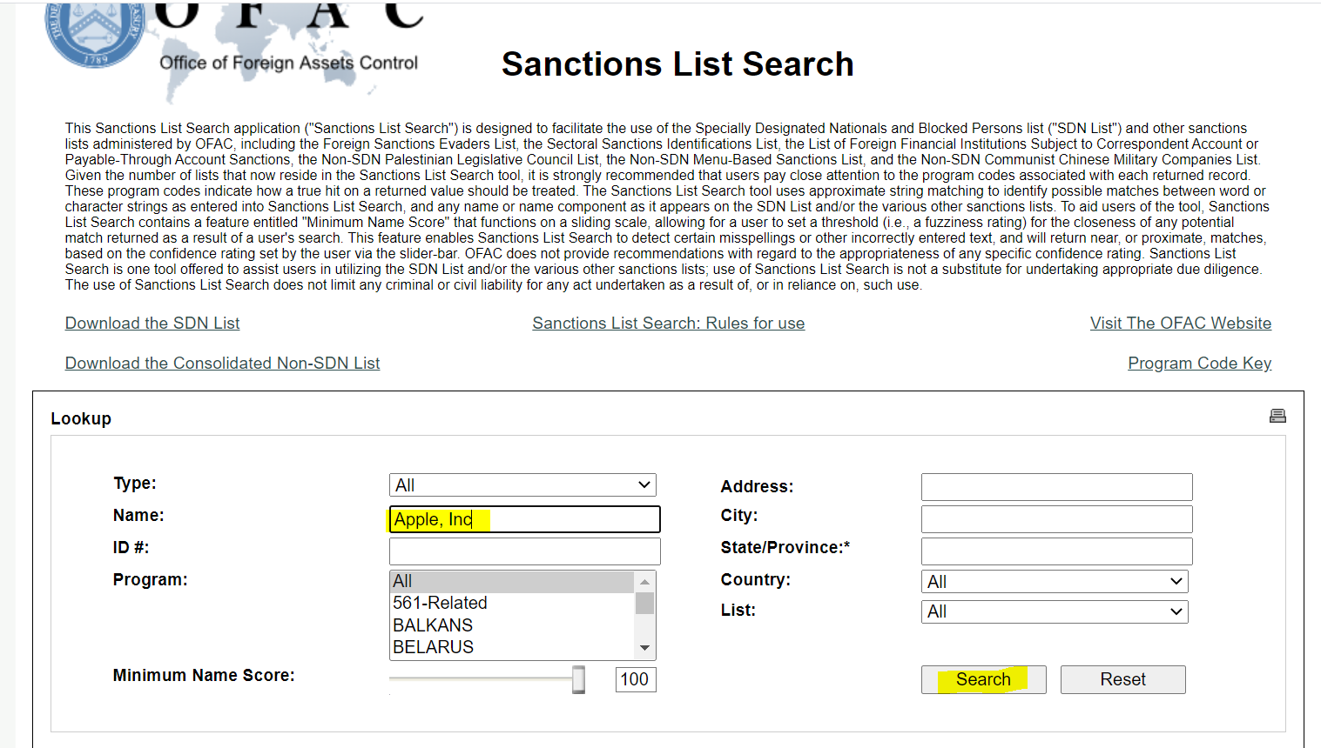
You should see No Results as below. Click Printer Icon on top right corner.
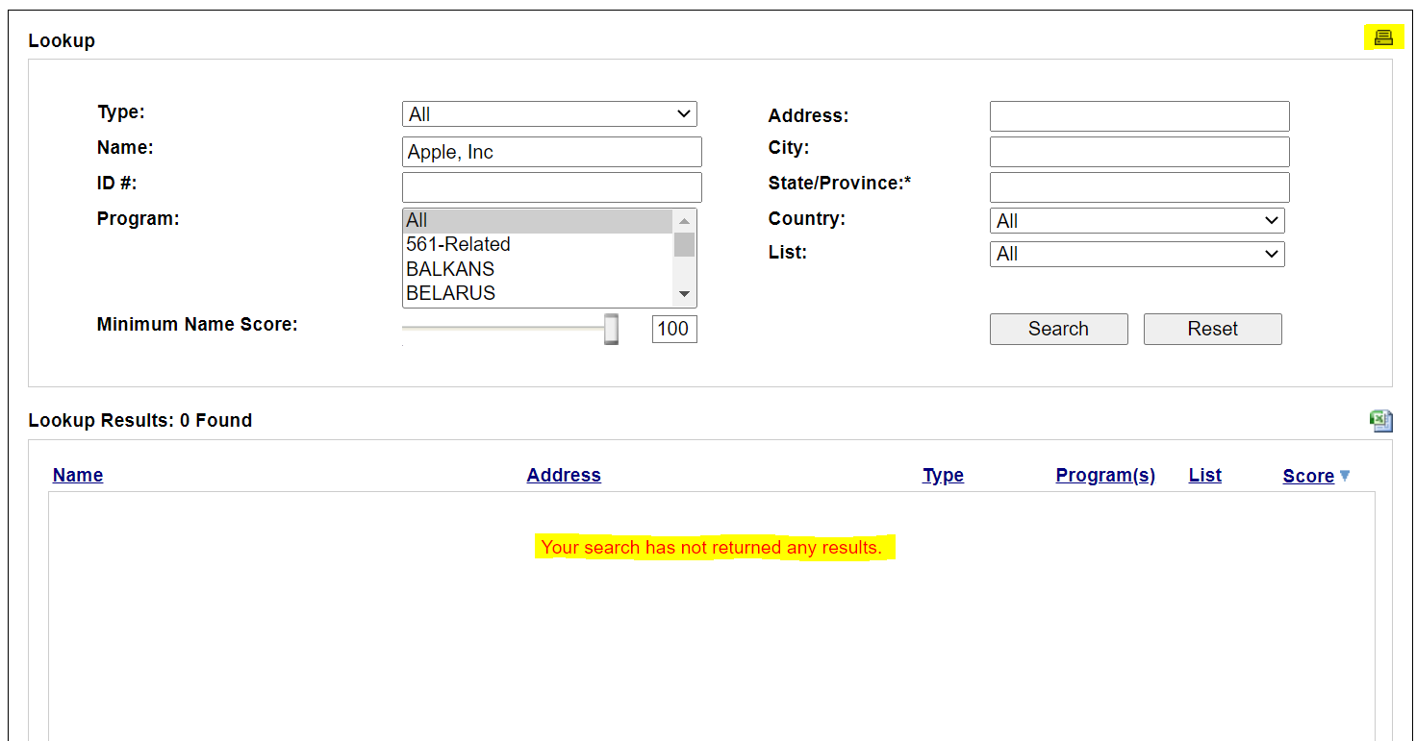

Save as PDF

**https://comptroller.texas.gov/purchasing/publications/divestment.php - This is the Comptroller site that has all the links except OFAC

You must go to each of the 5 links and save each PDF
